***PHARAMACY MANAGEMENT SYSTEM***

Sai Thejas Chillagatu Ramesh - 2837401

Veera Venkata Jagannadham Ganta - 2833181

Rama Koteswara Rao Kolla - 2835029

Rajasekhar Gali - 2836153

**USER MANUAL**

Step 1:

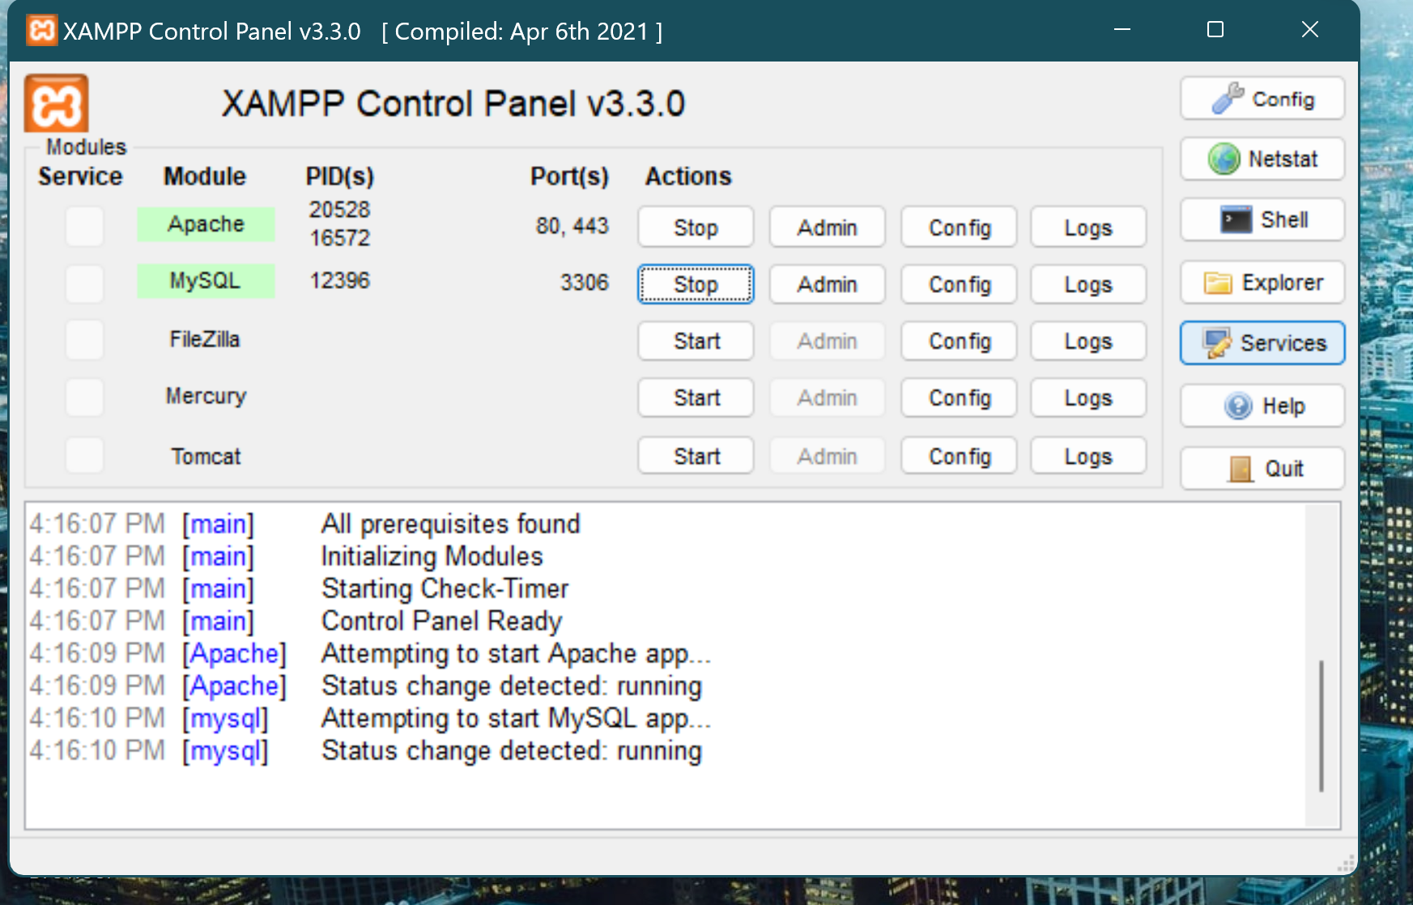

Start the Apache server and MySQL server.

Step 2:

Go to <http://localhost/phpmyadmin>

The whole database can be imported from an script file available at this link <https://github.com/thejas28/OOSE1/tree/main/Project/application/database>

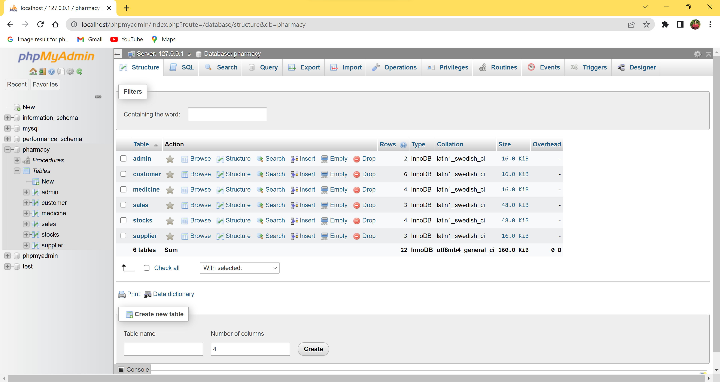

Create the database and its tables accordingly.

Step 3: The entire code of this project should be in the path shown in the snapshot below. the entire the code is available at this link

<https://github.com/thejas28/OOSE1/tree/main/Project>

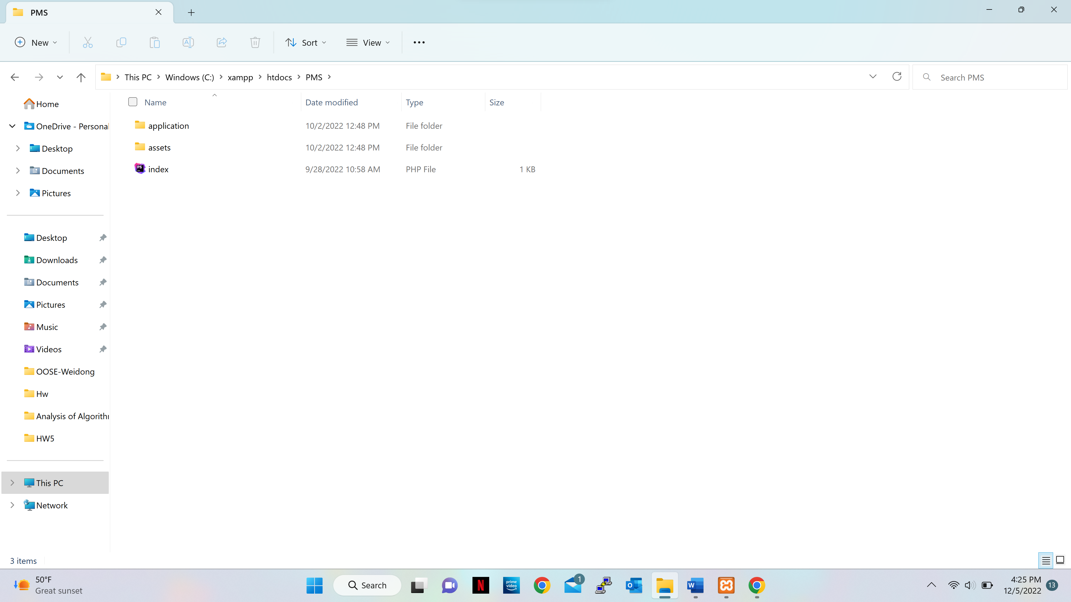

Step 4:

Go to google chrome and enter <http://localhost/PMS>

* **Login Page:**
* Admin needs to enter the email address and password.
* Login Credentials: Username: saithejas28@gmail Password: 12345

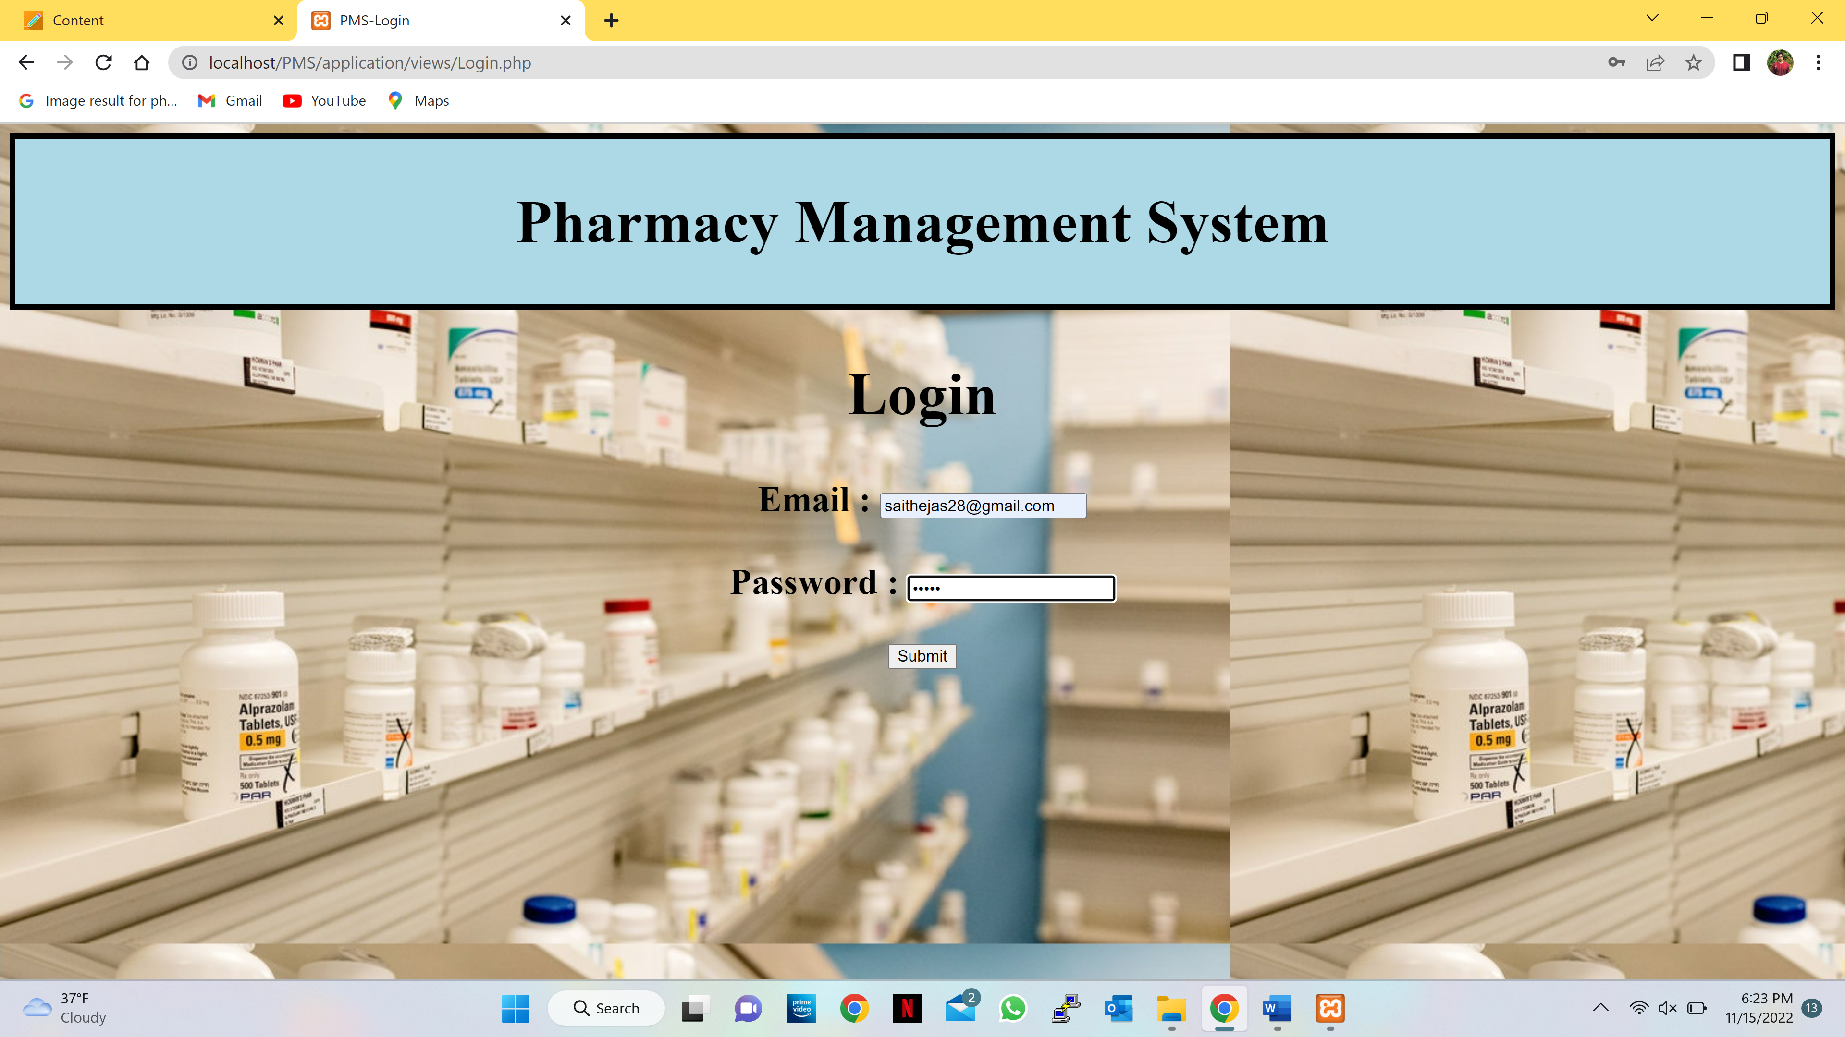

* If the admin enters the incorrect email address or password it displays a dialog if the admin selects ok it takes back to the Login page .

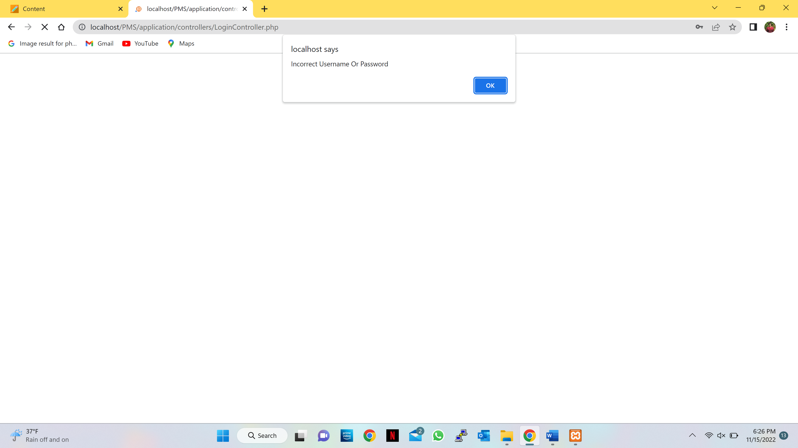

* If the admin enters the correct email address and password it gives an success message in the dialog.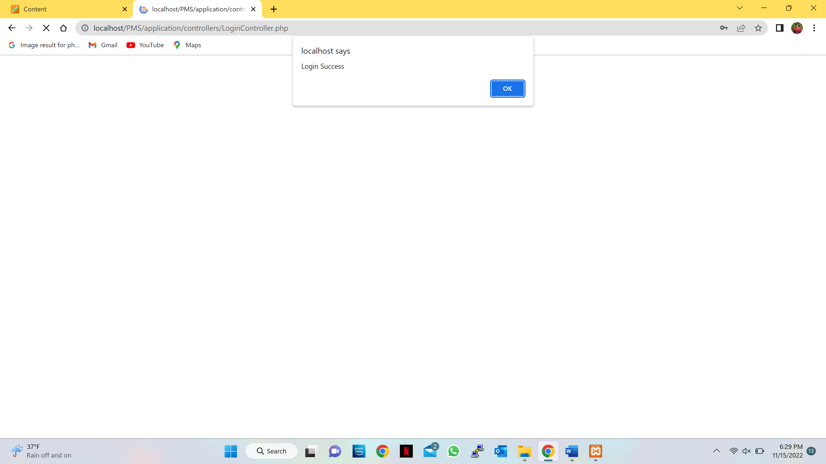
* After the success dialog it moves to the home page.
* **Home Page:**

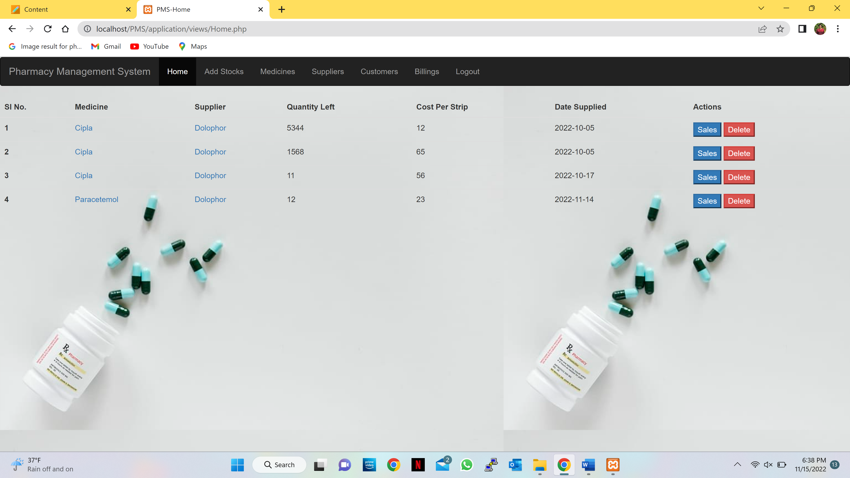

* The admin can see the available stock of medicines.
* The admin can delete the unavailable or expired medicines.
* The admin can go to the respective sales page by clicking the sales button respective to the medicine.
* **Sales Page:**

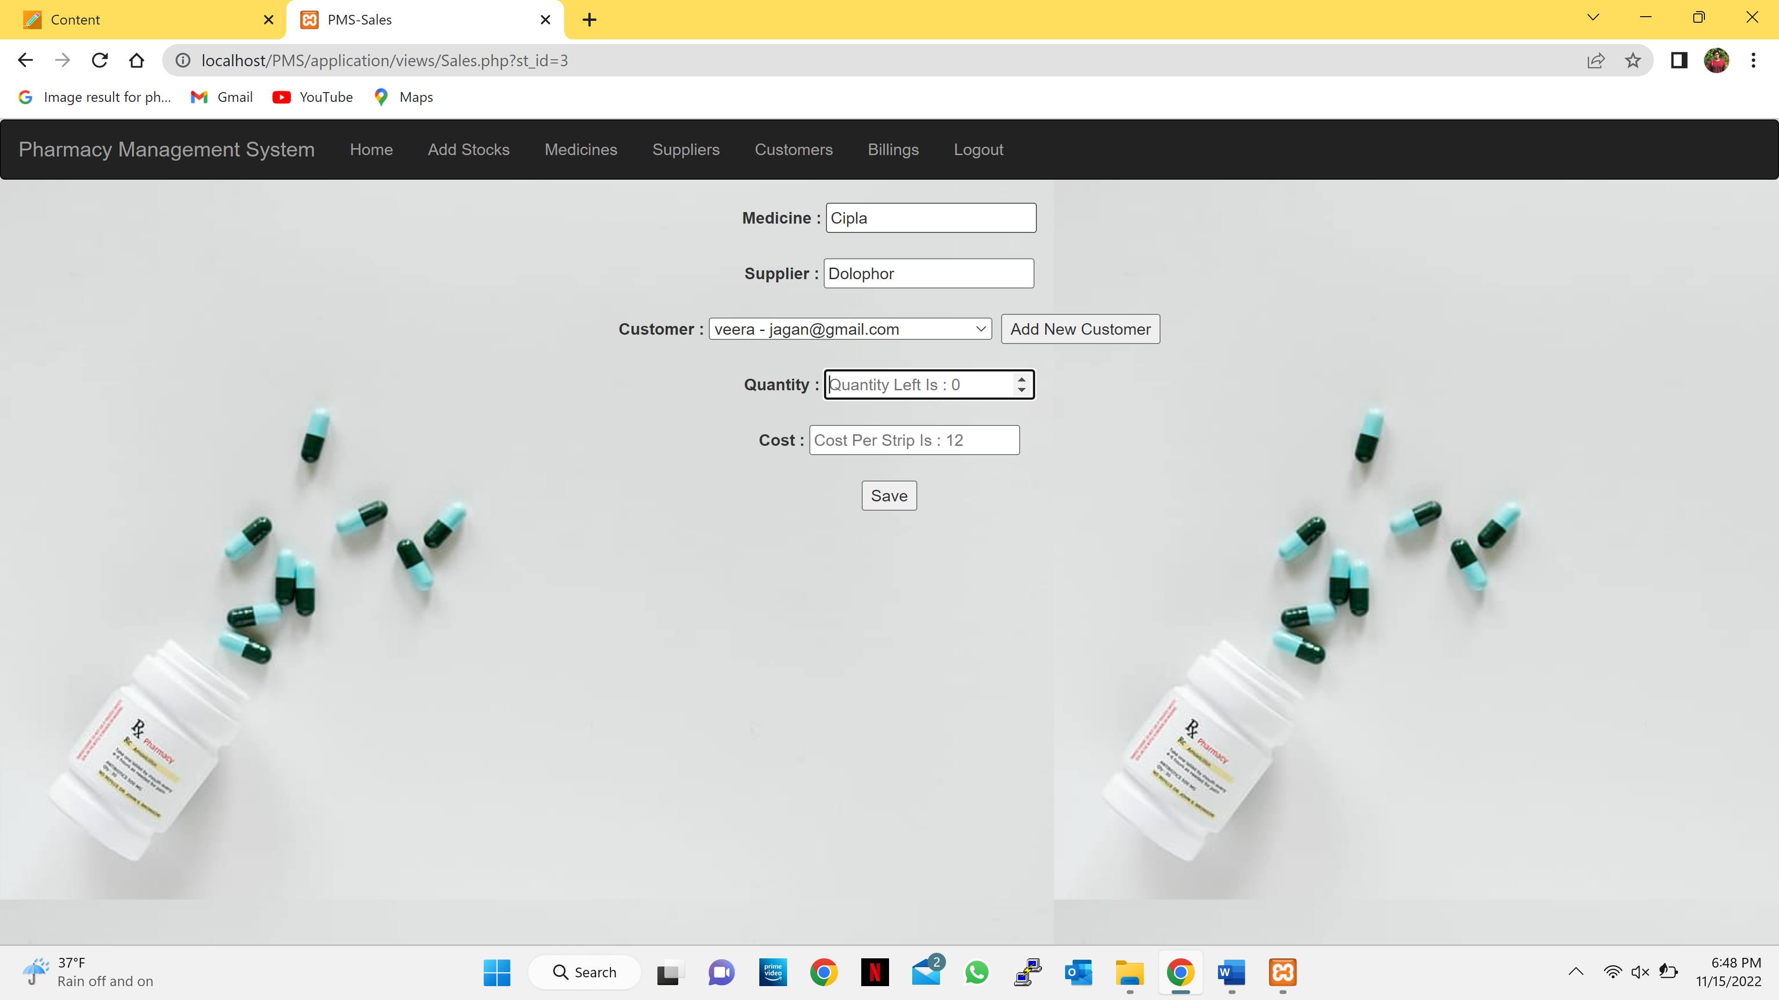

* If the stock is empty it will give you a dialog quantity left is 0.

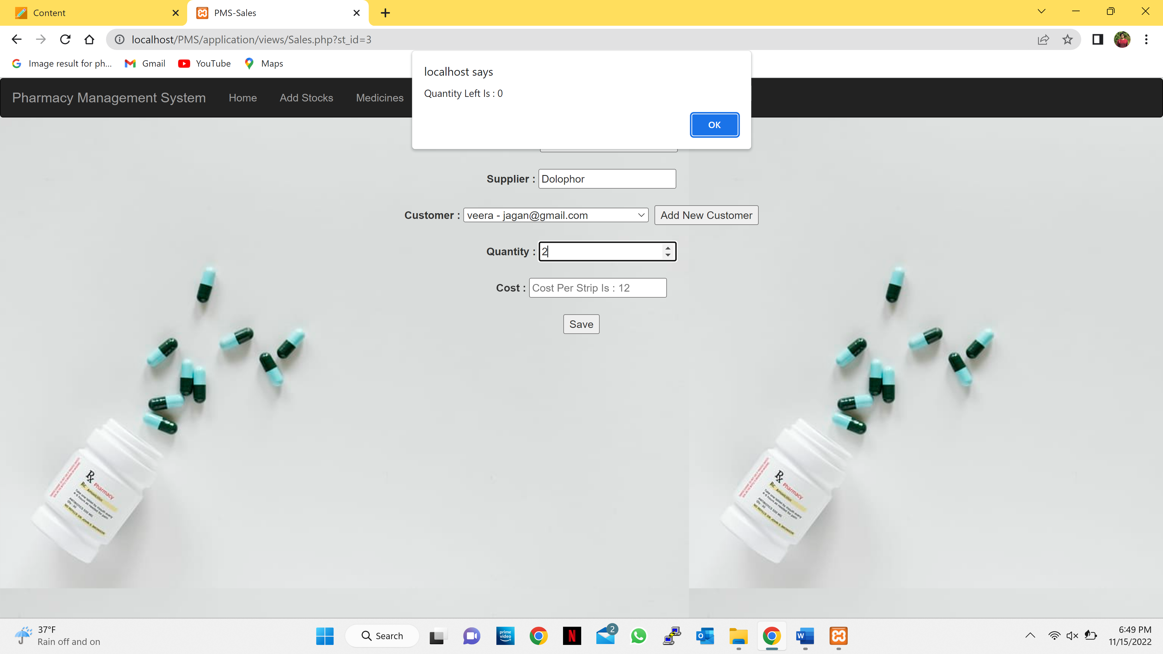

* If the stock is available admin can store the details of customer and how many medicines he is buying.

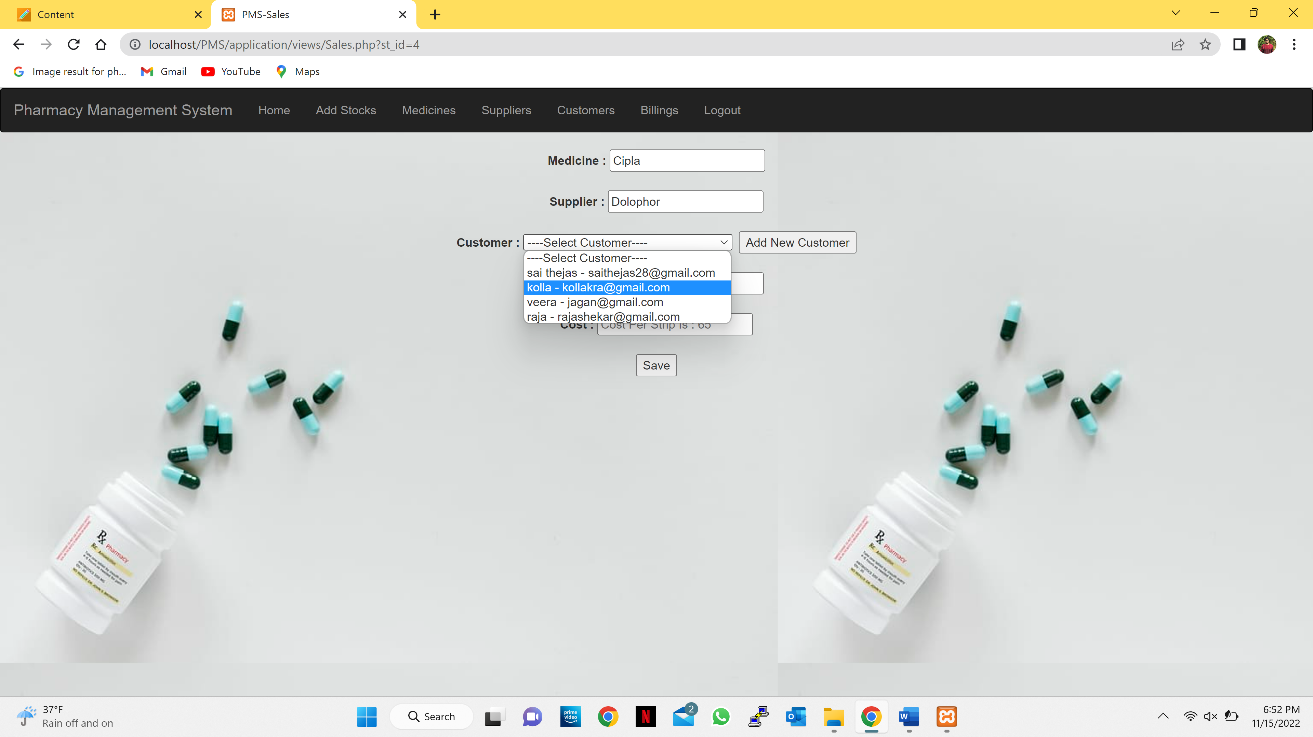

* If the customer is new, then the admin can store the customer’s detail by clicking the Add New Customer button which further takes to add customer page.
* **Add Customer Page:**
* Admin enters the details of customer and selects the add button.

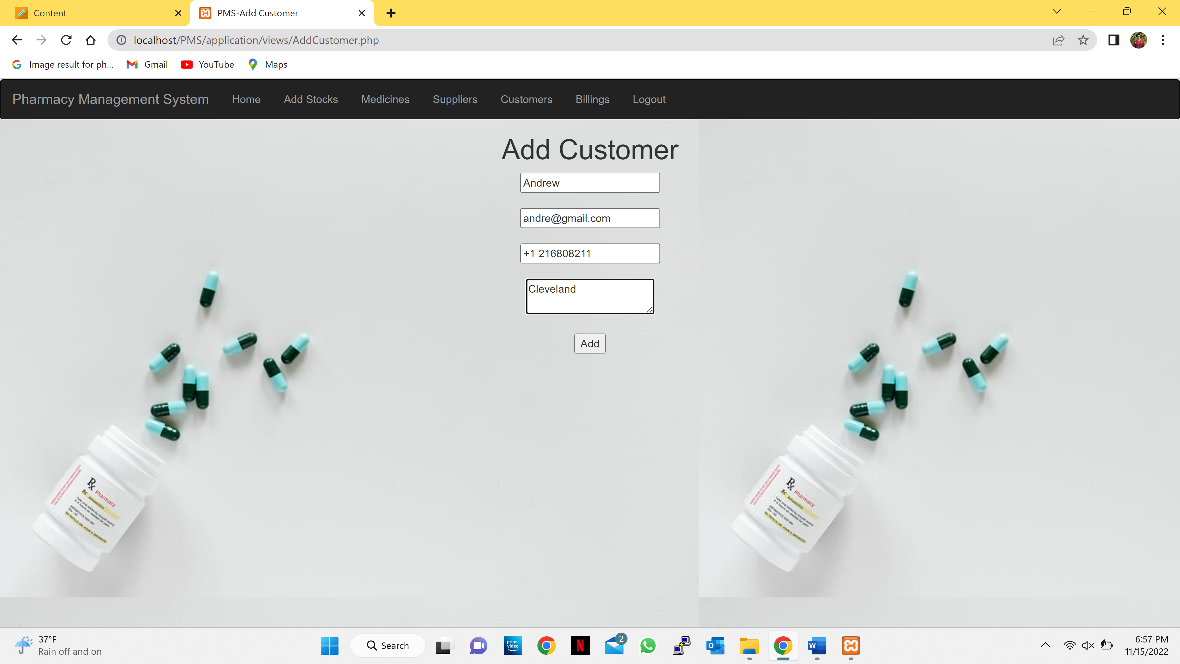

* As soon the admin selects the add button it gives an success message and takes back to the add customer page.

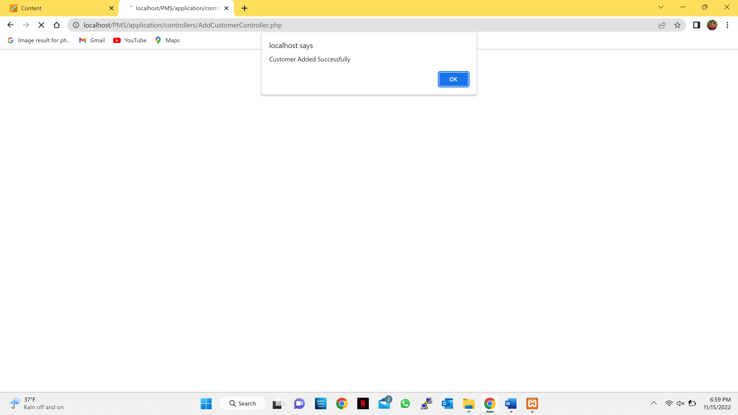

* Admin can add new medicine details by clicking the add new medicine button it moves to add medicine page.

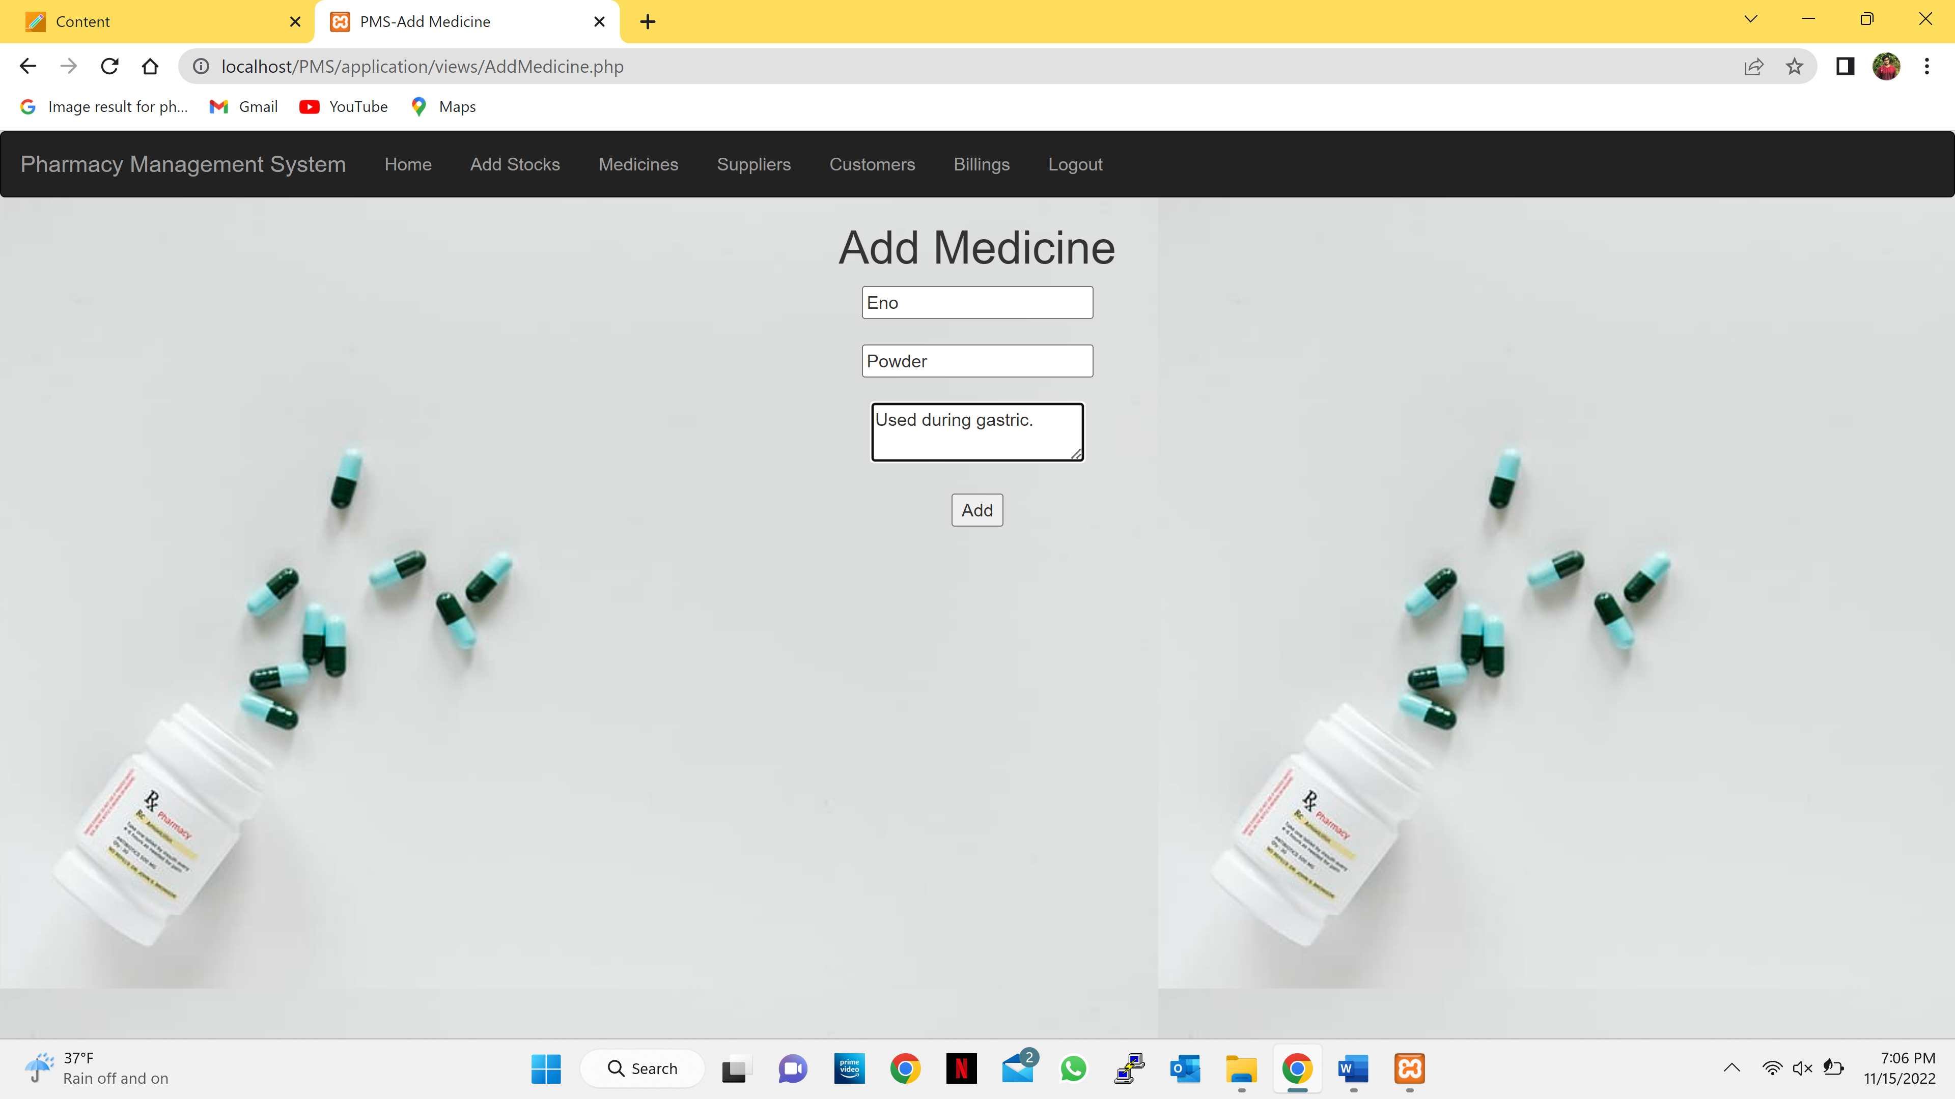

* Admin can add new supplier details by clicking the add new button it moves to add supplier page.

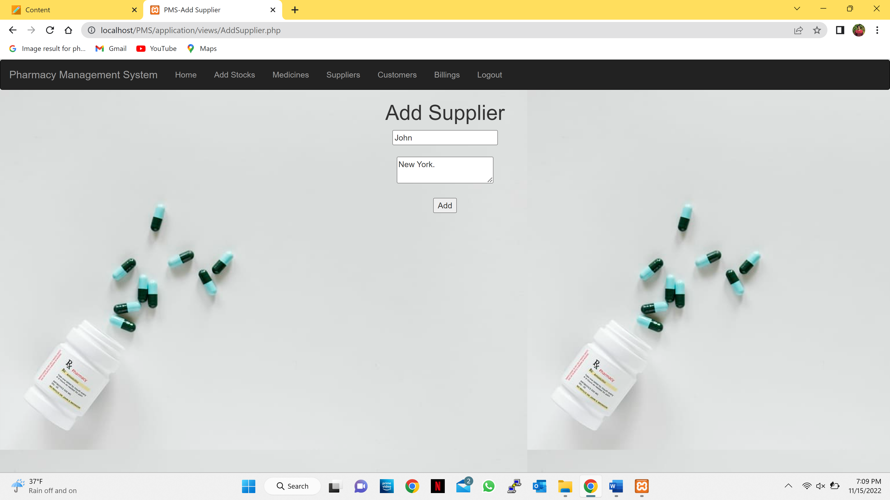

* **Add Stocks Page:**
* Admin can select the medicine and supplier, enter the quantity received cost per strip and change the date received.

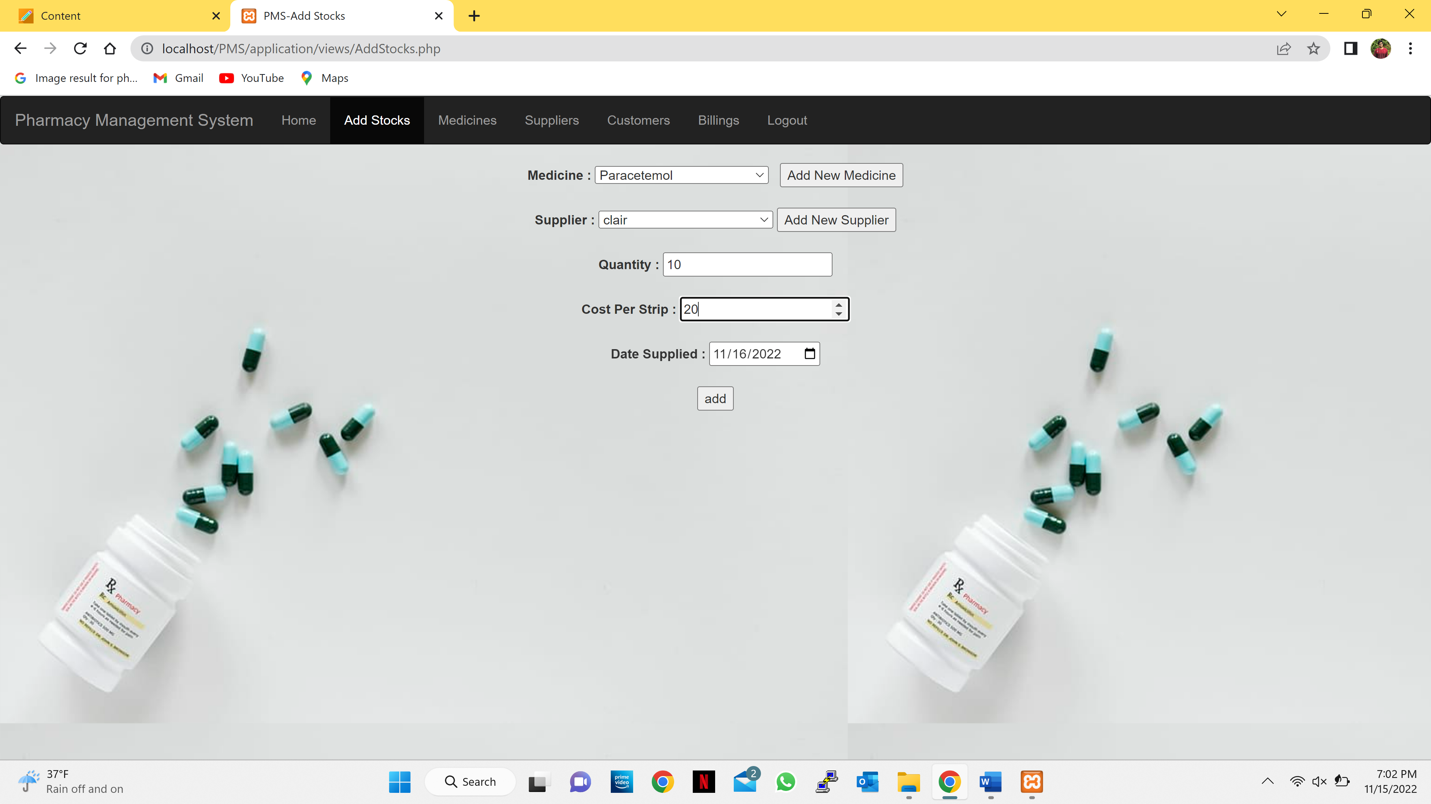

* After the admin enters the stock details and select the add button it will display a successful message.

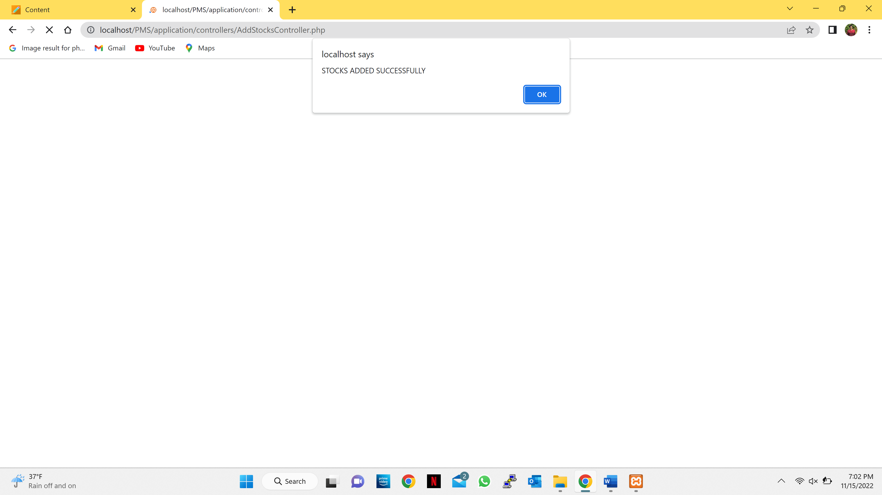

* **Medicine Page:**

Admin can see the available medicines in the store.

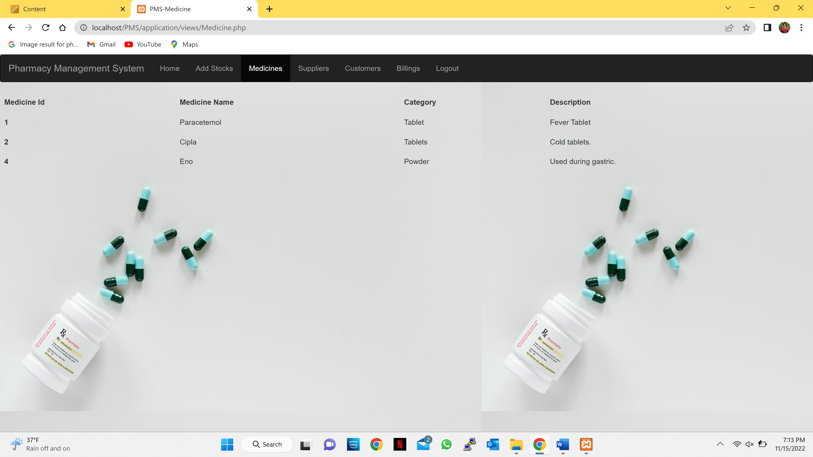

* **Supplier Page:**

Admin can see the supplier details.

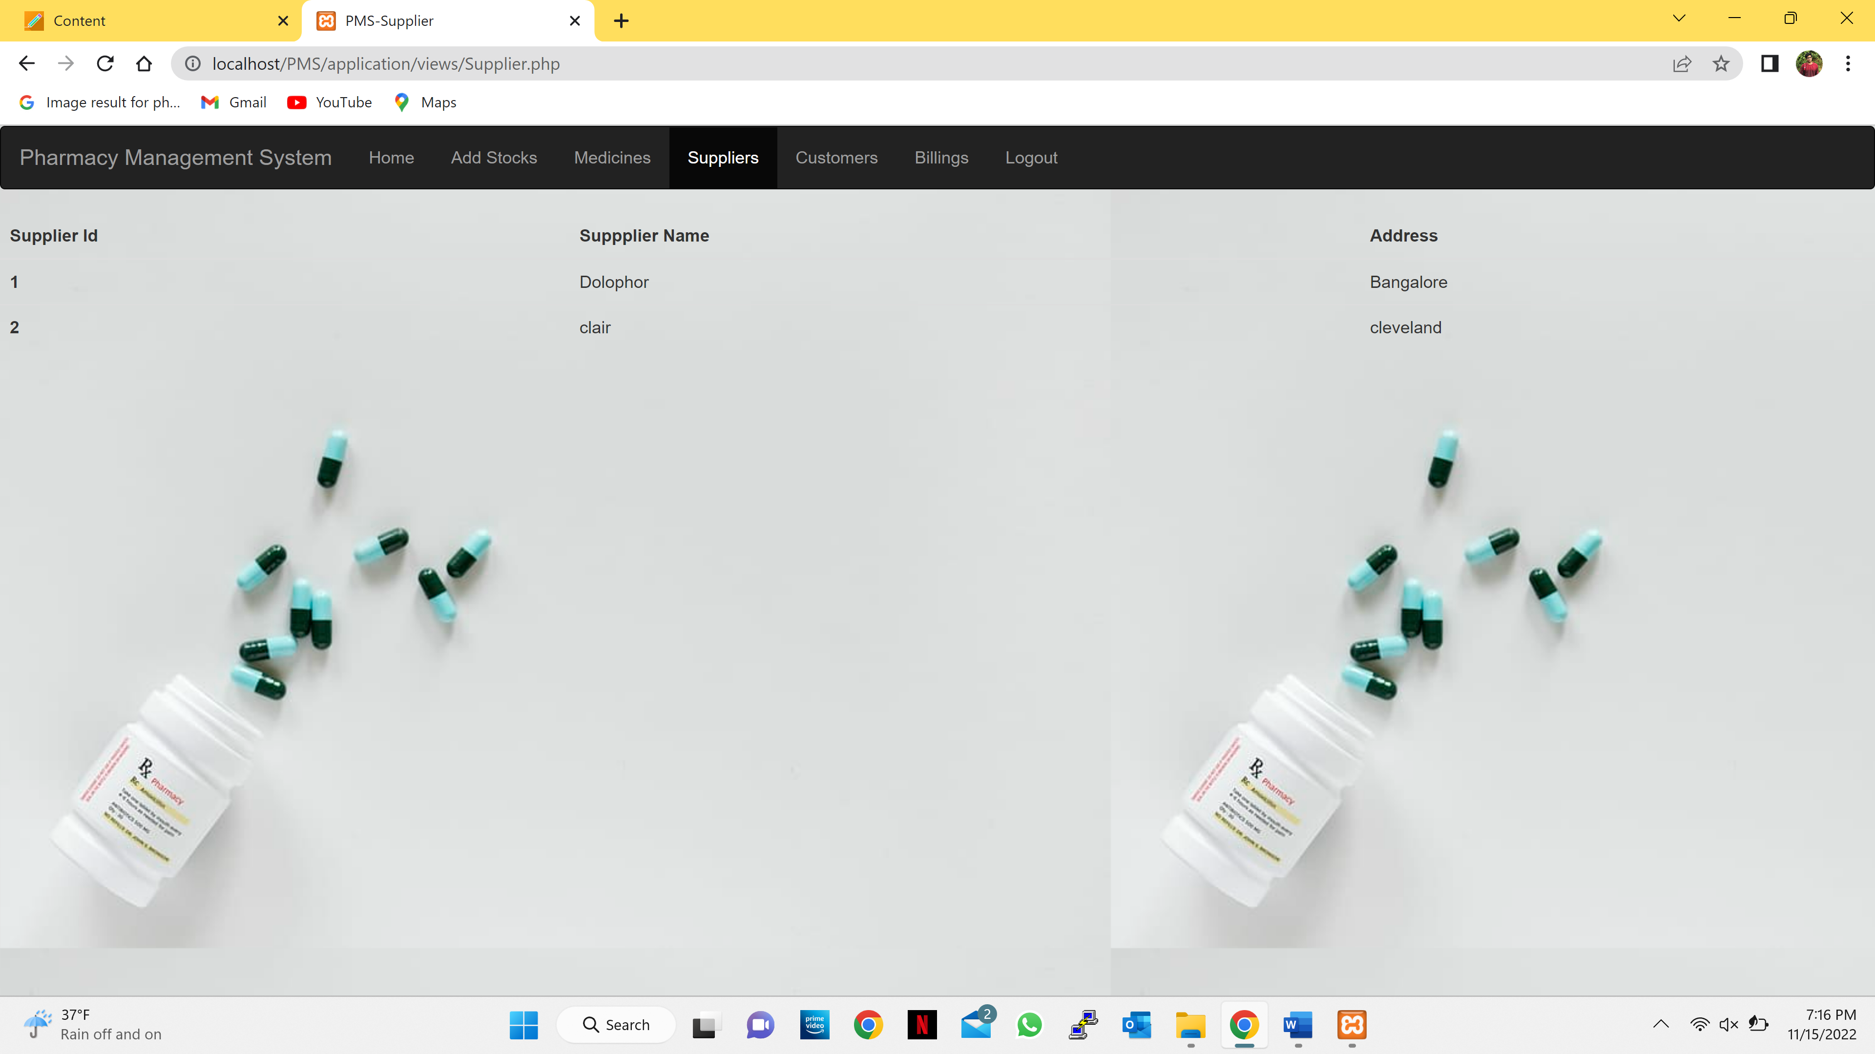

* **Customers Page:**

Admin can see the customer details.

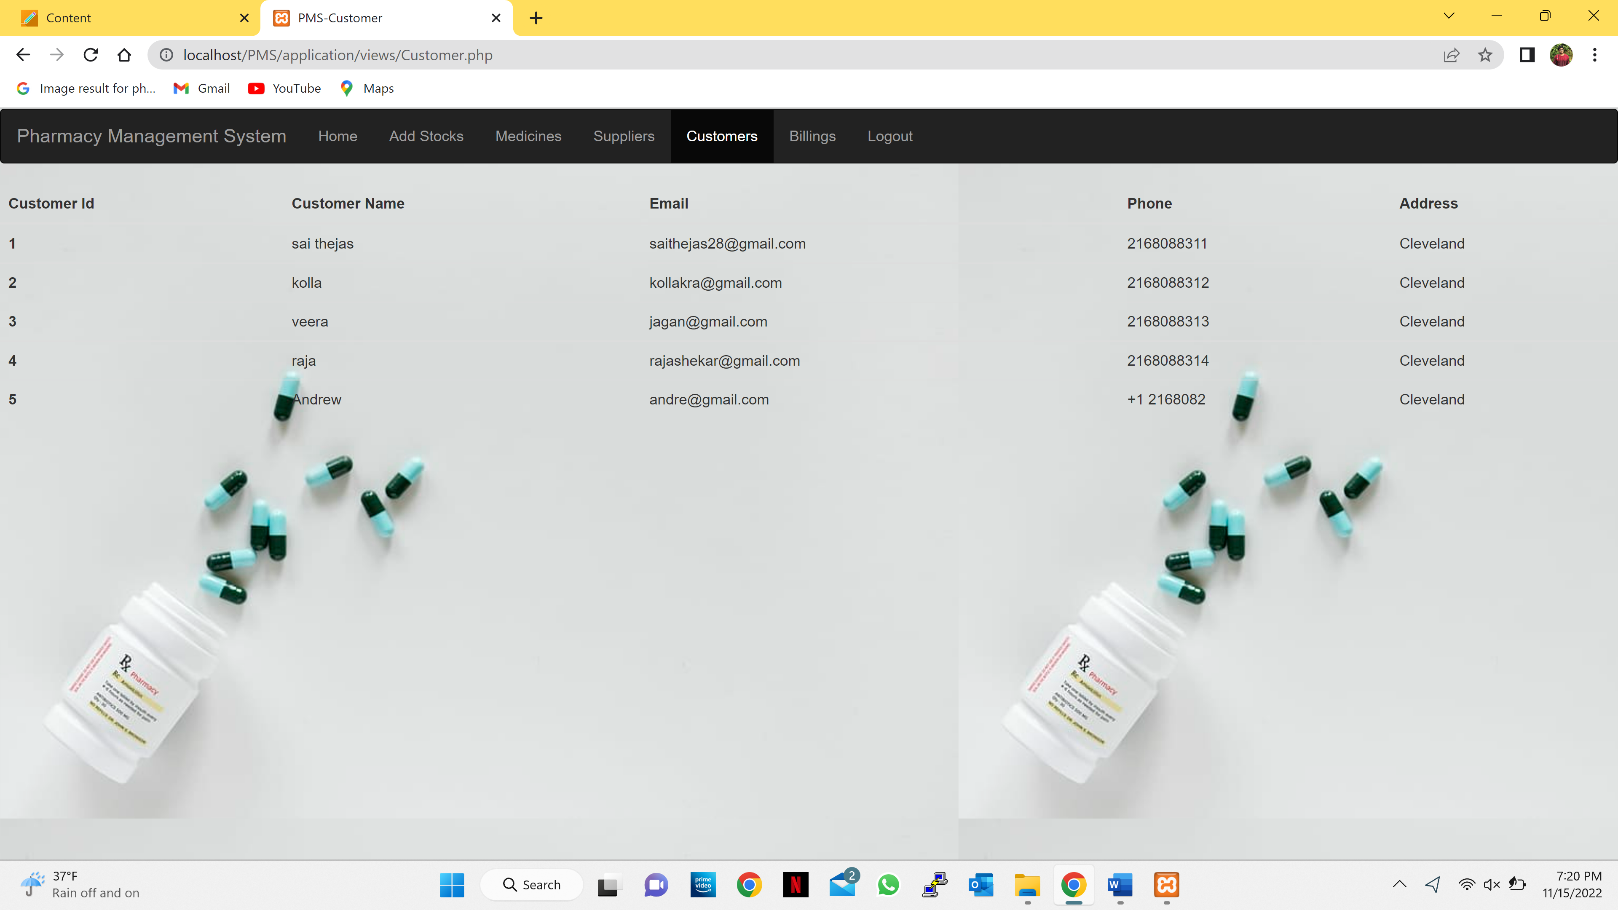

* **Billings page:**
* Admin can see all the billings.

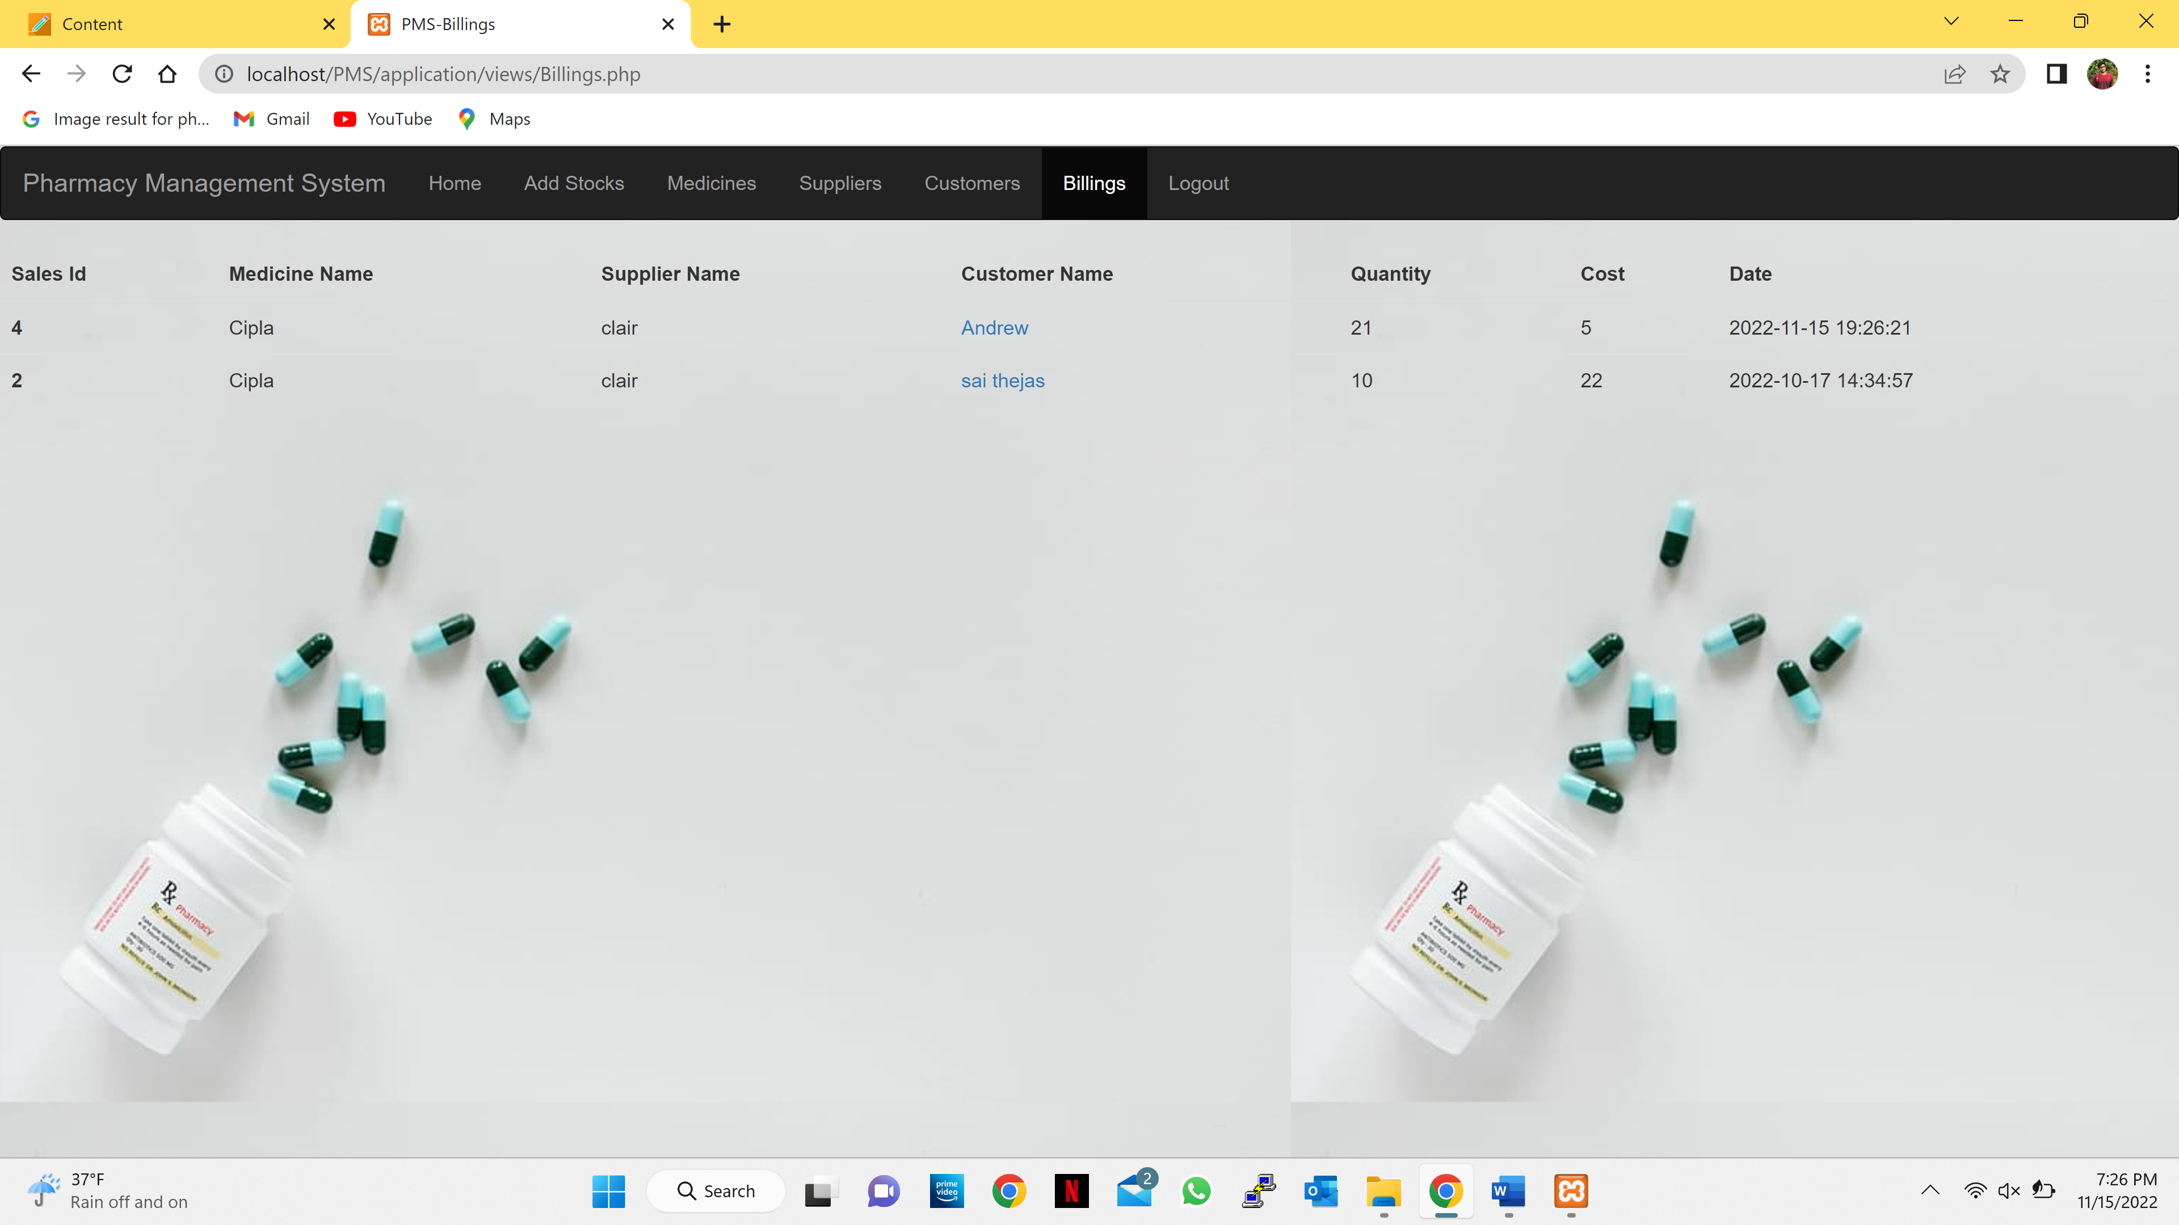

* Admin can also see the customer details individually by clicking on the name of the customer.

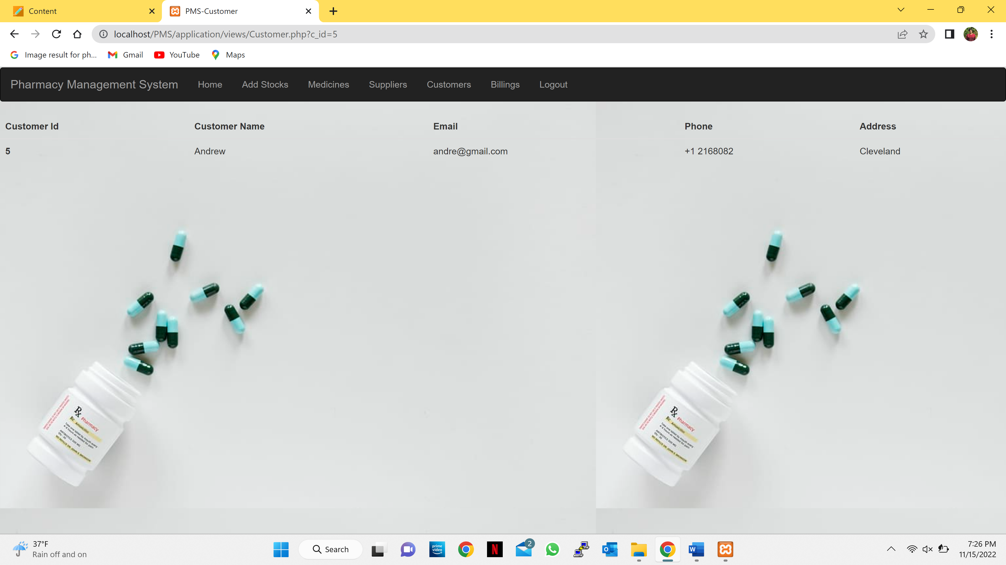

* **Logout:**
* After admin clicks logout, it will ask for confirmation for logging out.

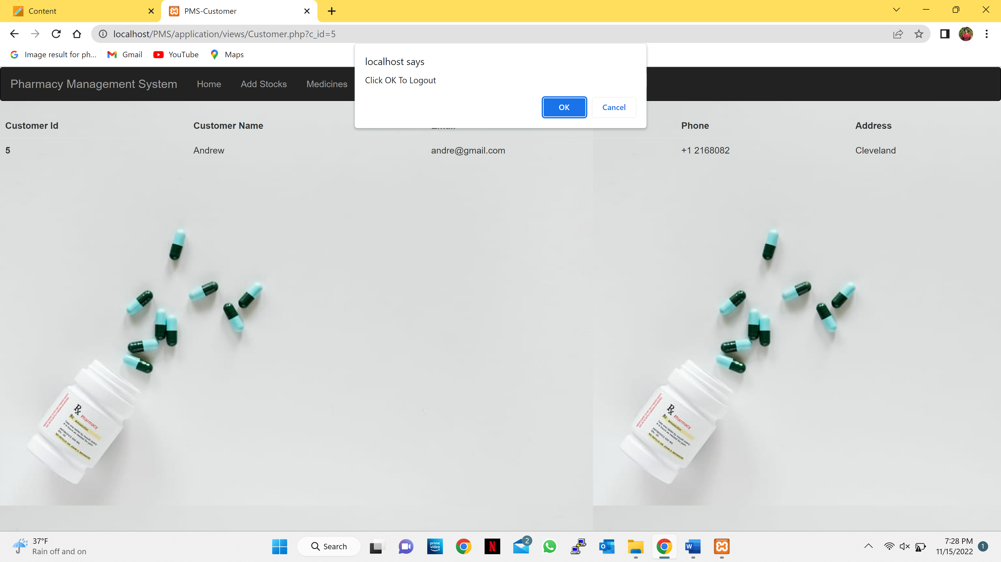

* After the admin selects the ok button, it will display an success message in dialog.

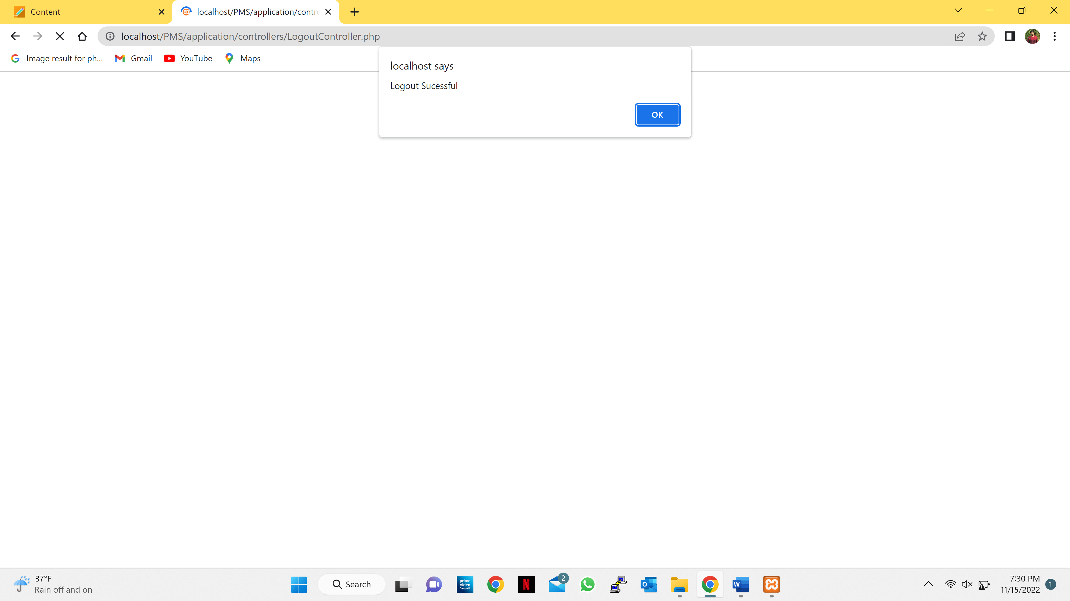

* After the admin selects the ok button, it will move back to the login page.